Introduction to AWS Core Technologies:

## Global Infrastructure

* Availability Zone
* Points of Presence
  + PoP consists of Edge Locations & Regional Edge Cache Servers
  + Used by AWS Cloud Front (Content Delivery Network) to deliver data , videos , Applications, API to customers
  + 22 Regions
  + 69 Availability Zones
  + 199 Edge locations
  + <https://www.infrastructure.aws/>
* Fault tolerance
* Low latency

## AWS Services

* Compute
* Storage
* Database
* Security
* Management
* Network

## EC2

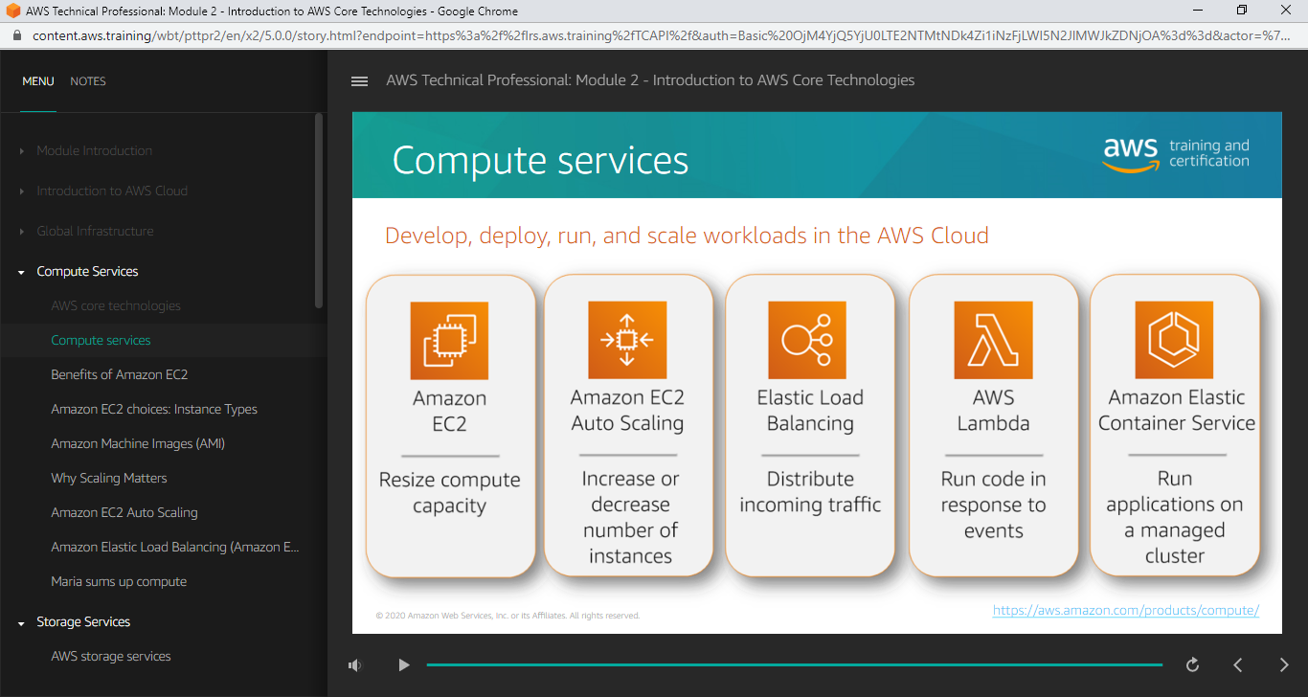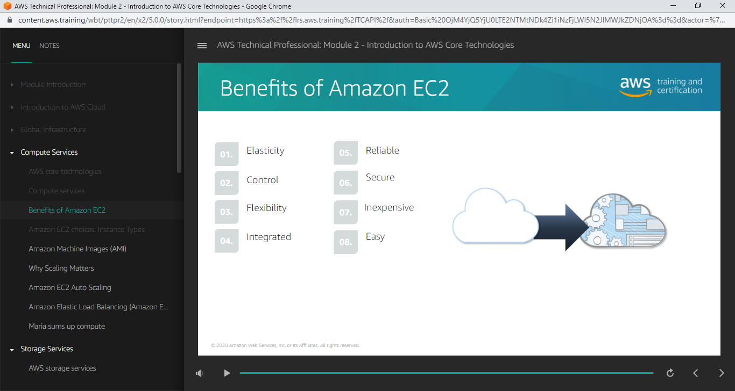

## Instance Types

Combination of CPU, Memory, Storage & Networking capacity (t2.micro, t2.nano)

## Instance Category

Instances are divided into below category:

* General purpose
  + It is a balanced one with combination of CPU, Memory, and Storage & Networking capacity
  + It can be used for variety of diverse workloads
* Compute Optimized
  + Ideal for compute specific applications
  + High performance processors
* Memory Optimized
  + Workloads that process large amount of data
* Accelerated Computing
  + Hardware accelerators / co processors to perform operations like floating-point number calculations, graphics processing, and data pattern matching.
  + Software running on cpu’s
* Storage Optimized
  + Workloads require high sequential read and write access to very large datasets stored in local

## AMI

AMI’s provided by

* AWS
* AWS markerplace
* AWS User community
* custom AMI’s

## Auto Scaling

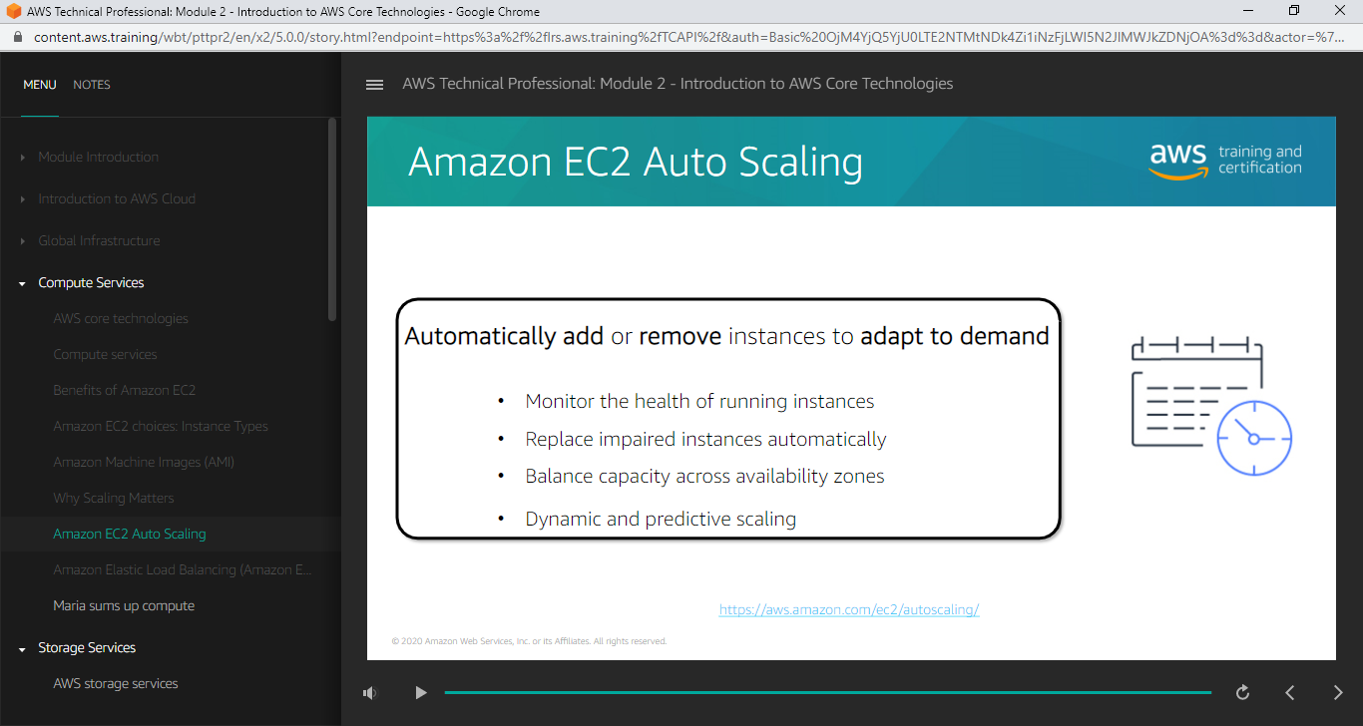

* Dynamic Scaling – Scales the instance dynamically at runtime
* Predictive scaling – Scales the instances based on scheduled (Predicted in advance)
* Both of these methods can be combined together

## Elastic Load Balancing

